**PATFIN NURSERY AND PRIMARY SCHOOL, AKESAN, LAGOS STATE.**

**SECOND TERM EXAMINATION [ 2018 / 2019 ]**

**CLASS : Primary 2**

**NAME : _____________________________ SUBJECT: ENGLISH LANGUAGE**

**INSTRUCTION : ANSWER CORRECTLY DURATION : 1 HOUR**

**Objectives**

***Read carefully and answer the questions.***

Fela was a musician. He is the father of Afrobeat. He sang against the bad things the government of his day was doing, his songs exposed the evil of the military. For this, he was hated by the government.

Many times he was arrested, attacked. Properties damaged and even his mother was thrown down from a storey building because of his songs.

Fela smoked and drank a lot. He has many wives like the biblical Solomon.

1. Who was Fela?

________________________________________________

1. Why did the government hate him so much?

________________________________________________

1. What happened to his mother?

________________________________________________

1. What bad habit did Fela have?

________________________________________________

1. What genre of music did Fela introduce? _________________

**Composition**

A market is a place where we _____________ and sell.

In Nigeria, we buy with the __________ and ______________.

Cows and goats ae slaughtered at the _____________.

A person who sells meat is called a ________________.

A person who sells fish is called ___________________.

A person who sells fresh fruits and vegetable is a ___________________.

**Grammar**

***Underline the correct answer.***

1. This is my book. It is ____________. (Me, Mine)
2. This is Shola’s dress. It is __________. (her, hers)
3. ____________ are the boys who stole your pen. (This, These)
4. Who __________ an eraser? (have, has)
5. This is ___________ book. (Mummys, Mummy’s)

**Literature**

**(Good Mama)**

**PATFIN NURSERY AND PRIMARY SCHOOL, AKESAN, LAGOS STATE.**

**SECOND TERM EXAMINATION [ 2018 / 2019 ]**

**CLASS : Primary 2**

**NAME : _____________________________ SUBJECT: BASIC SCIENCE**

**INSTRUCTION : ANSWER CORRECTLY DURATION : 1 HOUR**

**Objectives**

1. _____________ is an example of traditional drug. (a)Flagyl (b)Panadol (c)Pawpaw Seeds.
2. _____________ is not a characteristic of a drug abuser. (a)untidy appearance (b)normal speech (c)disobedience
3. ____________ is the right person to prescribe drugs. (a)teacher (b)doctor (c)traffic warden.
4. ____________ is the misuse of drugs. (a)drug abuse (b)drug (c)check up
5. Air-borne diseases are diseases caused by ______________. (a)wind (b)water (c)air

**Answer True/False**

1. air has weight. (True/False)
2. stone can float in air. (True/False)
3. water is wind in motion. (True/False)
4. air can blow dust into our eyes. (True/False)
5. open your mouth wide when coughing. (True/False)
6. it is good to sleep in an overcrowded room. (True/False)

**Fill in the gaps**

1. Clean water should be __________________________________.
2. Clean water should be __________________________________.
3. Clean water should be __________________________________.
4. Water is used for ____________________________.
5. _________________ can contaminate water.
6. Contaminated water can cause ____________________.
7. ____________ is used to prevent water contamination.
8. _______________ is used to purify water
9. Vomiting and excreting at the same time is a symptom of _______________.

**THEORY**

1. What is water?

______________________________________________________________________________________________________________________________

1. State qualities of clean water.
2. __________________________
3. ___________________________
4. ______________________________
5. Write 2 ways to prevent airborne diseases.
6. __________________________
7. ___________________________
8. ______________________________
9. What is purification?

______________________________________________________________________________________________________________________________

1. Write some ways we can purify water.
2. __________________________
3. ___________________________
4. ______________________________

**PATFIN NURSERY AND PRIMARY SCHOOL, AKESAN, LAGOS STATE.**

**SECOND TERM EXAMINATION [ 2018 / 2019 ]**

**CLASS : Primary 2**

**NAME : _____________________________ SUBJECT: SOCIAL SCIENCE**

**INSTRUCTION : ANSWER CORRECTLY DURATION : 1 HOUR**

**Objectives**

1. Drugs are the ____________ we use when we are sick. (a)alcohols (b)medicine (c)liquid
2. One of the signs to identify a drug abused person is through _____________. (a)untidy (b)neat (c)good
3. Drug abused persons always like to cause __________. (a)quarrel (b)joy (c)happiness
4. Among the damaging effect of drug abuse is brain ___________. (a)widening (b)damage (c)enlargement
5. __________ is a common illness. (a)boil (b)yawning (c)malaria

**Fill in the gaps**

1. _____________ are used to cure illness.
2. Taking drugs without doctor’s prescription ___________.
3. _____________ is a commonly abused drug.
4. ___________ is one way to help people who have abused drugs.
5. _______________ is caused by mosquito bite.

**Answer Yes/No**

1. Niraquire is commonly abused. (Yes/No)
2. Panaldol is a traditional drug. (Yes/No)
3. Drug abusers are taking to a dentist. (Yes/No)
4. High body temperature is a sign of good health. (Yes/No)
5. Clean water causes disentry. (Yes/No)

**Answer True/False**

1. Is it safe to swallow drugs anyhow? (True/False)
2. Some drugs makes us over-excited. (True/False)
3. Some drugs makies us feel better. (True/False)
4. Some drugs makes one do bad things when taken in excess. (True/False)
5. Some drugs make wound heal faster (True/False)

**THEORY**

1. What are drugs?

____________________________________________________________________________________________________________________________________________________________________________________________________

1. Give 5 examples of common drugs.
2. __________________________
3. ___________________________
4. ______________________________
5. ______________________________
6. ______________________________
7. What is drug abuse?

____________________________________________________________________________________________________________________________________________________________________________________________________

1. Write two ways to identify a drug abused person.
2. ______________________________
3. ______________________________
4. What does Illness mean?

____________________________________________________________________________________________________________________________________________________________________________________________________

1. Write 5 common illness.
2. __________________________
3. ___________________________
4. ______________________________
5. ______________________________
6. ______________________________
7. Write out 5 symptoms a sick person might experience.#
8. __________________________
9. ___________________________
10. ______________________________
11. ______________________________
12. ______________________________

**PATFIN NURSERY AND PRIMARY SCHOOL, AKESAN, LAGOS STATE.**

**SECOND TERM EXAMINATION [ 2018 / 2019 ]**

**CLASS : Primary 2**

**NAME : _____________________________ SUBJECT: P. H. E**

**INSTRUCTION : ANSWER CORRECTLY DURATION : 1 HOUR**

**Objectives**

1. Tennis is a game for ___________ players. (a)1 (b)2 (c)4
2. ____________ is used to hit the ball in tennis. (a)basket (b)wacket (c)racket
3. ___________ is a ball game. (a)coffee grinder (b)bend knee (c)cricket
4. ___________ is not a skill in football. (a)passing (b)heading (c)rebound
5. A ______________ is need to conduct the game in football. (a)goal keeper (b)coach (C)referee

**Answer True/False**

1. Swimming is a water game. (True/False)
2. A cap is worn to protect the hair from getting wet. (True/False)
3. A baker is needed in swimming. (True/False)
4. Volleyball is a game of eleven players. (True/False)
5. Cricket is played on the grass. (True/False)

**Fill in the gap**

1. ___________ should not swim in the shallow areas of the pool.
2. A ______________ is worn to prevent drowning.
3. Shooting is done in _____________ game.
4. Football to is played on the _______________.
5. A ______________ is worn to swim.

**Answer Yes/No**

1. Exercise is bad for us (Yes/No)
2. Pushing is not allowed in football. (Yes/No)
3. Gloves are used in tennis. (Yes/No)
4. Sandals are the right footwear in swimming. (Yes/No)
5. Beginners can use shallow water for practice. (Yes/No)

**THEORY**

1. List 5 safety rules in swimming
2. __________________________
3. ___________________________
4. ______________________________
5. ______________________________
6. ______________________________
7. List 5 ball games you know.
8. __________________________
9. ___________________________
10. ______________________________
11. ______________________________
12. ______________________________
13. Draw a racket.
14. List 2 skills in tennis.
15. ______________________________
16. ______________________________
17. List 2 rules in football
18. ______________________________
19. ______________________________

**PATFIN NURSERY AND PRIMARY SCHOOL, AKESAN, LAGOS STATE.**

**SECOND TERM EXAMINATION [ 2018 / 2019 ]**

**CLASS : Primary 2**

**NAME : _____________________________ SUBJECT: HOME ECONOMICS**

**INSTRUCTION : ANSWER CORRECTLY DURATION : 1 HOUR**

**Objectives**

1. _______________ is a part of our body that needs to be brushed twice daily.
2. _____________ is worn to prevent the foot from injury.
3. ______________ is the way we keep our body when sitting, standing, walking. E.t.c.
4. We must sleep for at least _____________ hours.
5. ____________ is a traditional fabric for Yoruba men.

**Choose the right options**

1. It is good to maintain a ____________ posture. (a)wrong (b)correct (c)long
2. We need to rest and sleep very well in order to be _____________. (a)weak (b)deep (c)strong
3. We wear clothes to ___________ our body. (a)expose (b)open (c)cover
4. _____________ are worn on Sports Day. (a)clogs (b)heals (c)canvass
5. ________ is longer than rest. (a)bath (c)sleep (c)exercise

**Answer Yes/No**

1. When we rest and sleep well we will do well at school. (Yes/No)
2. Clothing is a form of identification. (Yes/No)
3. Our hair should be brushed once a week. (Yes/NO)
4. We should bath once a day? (Yes/No)
5. Beads are worn on the shoulders. (Yes/No)

**THEORY**

1. What are clothes?

____________________________________________________________________________________________________________________________________________________________________________________________________

1. What are footwears?

___________________________________________________________________________________________________________________________________________________________________________________________________

1. Give 2 reasons why we need rest and sleep.
2. ____________________________________________________________
3. ____________________________________________________________
4. Name two(2) professions and their duties .

|  |  |  |
| --- | --- | --- |
|  | **Professions** | **Duties** |
| 1. |  |  |
| 2. |  |  |

**PATFIN NURSERY AND PRIMARY SCHOOL, AKESAN, LAGOS STATE.**

**SECOND TERM EXAMINATION [ 2018 / 2019 ]**

**CLASS : Primary 2**

**NAME : _____________________________ SUBJECT: CIVIC EDUCATION**

**INSTRUCTION : ANSWER CORRECTLY DURATION : 1 HOUR**

**Objectives**

1. A ______________ stands up for his country.
2. ___________________ are things that identifies us as Nigerians
3. Good citizens pay ________________.
4. _______________ is a kind of government where people choose their leaders.
5. I come from ______________ state.

**Choose the right options**

1. Nigeria is a _______________. (a)nation (b)continent (c)constituency
2. One of the benefits of democracy is freedom of _____________. (a)riot (b)speed (c)corruption
3. Citizens are free to join any __________ of their choice. (a)riot (b)religion (c)colour
4. Our currency is our national ___________. (a)element (b)identity (c)colour
5. When you believe that your country is better than others, you are a __________. (a)parrot (b)patriot (c)proprietor

**Answer Yes/No**

1. Language is not an identity. (Yes/No)
2. We have a right to education. (Yes/No)
3. Our National Anthem is only a stanza. (Yes/No)
4. There is no pledge after the Anthem. (Yes/No)
5. We can dance to the Anthem. (Yes/No)

**Answer True/False**

1. Patriotism brings development. (True/False)
2. In a democratic government, people can say how they feel. (True/False)
3. You are a Nigerian. (True/False)
4. Your school is in Alimosho Local Government. (True/False)
5. The Nigerian flag is Green and Yellow. (True/False)

**THEORY**

1. What is democracy.

___________________________________________________________________________________________________________________________________________________________________________________________________

1. Write out 5 democratic benefits you know.
2. ____________________________________________________________
3. ____________________________________________________________
4. ____________________________________________________________
5. ____________________________________________________________
6. ____________________________________________________________
7. Write out 2 benefits of patriotism.
8. ____________________________________________________________
9. ____________________________________________________________
10. Draw and colour the flag.

**PATFIN NURSERY AND PRIMARY SCHOOL, AKESAN, LAGOS STATE.**

**SECOND TERM EXAMINATION [ 2018 / 2019 ]**

**CLASS : Primary 2**

**NAME : _____________________________ SUBJECT: Security Education**

**INSTRUCTION : ANSWER CORRECTLY DURATION : 1 HOUR**

**Objectives**

1. ___________ is anything that is against the law.
2. _____________ is the money paid to reduce a kidnapped victim.
3. _____________ is a number used to represent getting money by trick.
4. _____________ crimes happen during elections.
5. ______________ is the misuse of drugs

**Choose the correct option**

1. _______________ arrests criminals. (a)doctor (b)lawyer (c)police
2. Keeping a person without his or her approval is _____________. (a)kidnappping (b)adultnapping (c)childnapping
3. ______________ are sent to jail. (a)criminals (b)pupils (c)engineers
4. ______________ can make a person steal. (a)education (b)knowledge (c)poverty
5. _________ can be established to prevent crimes. (a)vocational centers (b)crimes (c)police station

**Answer YES | NO**

1. A drug abuser should be shown love. (True/False)
2. A bad family can make a person commit crimes. (True/False)
3. Religion can make a person commit crimes. (True/False)
4. EFCC stands for Economic and Financial Crimes Commission. (True/False)
5. ECPC stands for International Countries Policing Committee. (True/False)

**Answer Yes/No**

1. Avoid following bad gangs (Yes/No)
2. Let your parents known your friends (Yes/No)
3. Rape is a criminal activity. (Yes/No)
4. Joblessness can cause crime. (Yes/No)
5. A good child can become bad of he/her has bad friends. (Yes/No)

**THEORY**

1. List 5 criminal activities you know.
2. ___________________________
3. ___________________________
4. ___________________________
5. ___________________________
6. ___________________________
7. Write 2 ways to prevent crime.
8. ___________________________
9. ___________________________
10. Write the full meaning of: -

I) NDLEA: - __________________________________________________

II) ICPC: - ___________________________________________________

1. List 2 causes of crime.
2. ___________________________
3. ___________________________

**PATFIN NURSERY AND PRIMARY SCHOOL, AKESAN, LAGOS STATE.**

**SECOND TERM EXAMINATION [ 2018 / 2019 ]**

**CLASS : Primary 2**

**NAME : _____________________________ SUBJECT:**

**INSTRUCTION : ANSWER CORRECTLY DURATION : 1 HOUR**

**Objectives**

1. _____________ is needed in making Paper-Mache. (a)spit (b)oil (C)water
2. ______________ is used to bind paper together in Paper-Machec. (a)sugar (b)soil (c)starch
3. _____________ is not used to draw. (a)pen (b)colour (c)lipstick
4. D: r: m: f: s: l: t: d: is ___________. (a)Tonic Piano (b)Tonic Trumpet (c)Tonic Solfa
5. ________________ is a traditional fabric. (a)velvet (b)jeans (c)adire

**Fill in the gaps**

1. ______________ is a traditional fabric worn by the Hausas
2. An ____________ is a male who acts plays.
3. An ____________ is a female who acts plays
4. __________ and _____________ are worn by Ibo women.
5. _____________ and _______________ are worn by Yoruba women.

**Answer Yes/No**

1. Paper mache needs the sun for it to dry. (Yes/No)
2. Coil is used in making paper mache. (Yes/No)
3. Music is pleasant to the ears. (Yes/No)
4. Traditional fabrics tell people about where we are from. (Yes/No)
5. The Hausa’s put on Akwete. (Yes/No)

**Answer True/False**

1. Plays are acted in the stage. (Yes/No)
2. People watching a plays are the audience. (Yes/No)
3. Costumes are needed in acting. (Yes/No)
4. Accessories are not used in acting. (Yes/No)
5. Walking sticks are used by women. (Yes/No)

**THEORY**

1. What is Acting?

_________________________________________________________________________________________________________________________________________________________________________________________

1. How do we make a Paper Mache?

_________________________________________________________________________________________________________________________________________________________________________________________

_________________________________________________________________________________________________________________________________________________________________________________________

1. Mention all the Make-ups needed for acting
2. ____________________________
3. ____________________________
4. ____________________________
5. ____________________________
6. Write out the accessories needed in acting.
7. ____________________________
8. ____________________________
9. ____________________________
10. ____________________________
11. ____________________________
12. ____________________________

**PATFIN NURSERY AND PRIMARY SCHOOL, AKESAN, LAGOS STATE.**

**SECOND TERM EXAMINATION [ 2018 / 2019 ]**

**CLASS : Primary 2**

**NAME : _____________________________ SUBJECT: C. R. K.**

**INSTRUCTION : ANSWER CORRECTLY DURATION : 1 HOUR**

**Objectives**

1. ______________ is the bread of life.
2. Jesus is the good ________________
3. ______________ are the salt of the earth
4. _______________ was hospitable to angels
5. ________________ gave prophet Elijah

**Choose the right options**

1. The bread of life is the _____________ of God. (a)way (b)mind (c)word
2. Jesus gives ___________ unto the world. (a)Life (b)food (c)mind
3. A good shepherd will take ___________ of his animals. (a)care (b)nothing (c)way
4. A good shepherd will always live for any _________ sheep. (a)old (b)lost (c)fat
5. A good shepherd should be ___________. (a)kind (b)wicked (c)angry

**Answer Yes/No**

1. Salt is Yellow? (Yes/No)
2. Salt makes food taste better. (Yes/No)
3. Light makes us see. (Yes/No)
4. Light attracts flies. (Yes/No)
5. True Christians must preach. (Yes/No)

**Answer True/False**

1. Abraham sent his guest away. (True/False)
2. We must treat visitors well. (True/False)
3. Abraham entertained pupils. (True/False)
4. Abraham had many sons. (True/False)
5. Bread is made from sand. (True/False)

**THEORY**

1. What is Hospitality?

__________________________________________________________________________________________________________________________________________________________________________________________

1. Mention 2 people that were hospitable in the bible.
2. __________________________
3. _____________________________
4. In what ways are Christians salt of the world?
5. __________________________________________________________________________________________________________________________________________________________________________________________
6. List 3 things Christians use to spread the gospel.
7. _________________________________
8. _________________________________
9. _________________________________

**PATFIN NURSERY AND PRIMARY SCHOOL, AKESAN, LAGOS STATE.**

**SECOND TERM EXAMINATION [ 2018 / 2019 ]**

**CLASS : Primary 2**

**NAME : _____________________________ SUBJECT: Agric**

**INSTRUCTION : ANSWER CORRECTLY DURATION : 1 HOUR**

**Objectives**

1. ______________ is a diet that contains all the classes of food.
2. Beans gives ____________________________
3. Rice gives ______________________________
4. Oranges gives ____________________________
5. Garden eggs gives ____________________________

**Answer True/False**

1. Unbalanced diet causes stunted growth. (True/False)
2. Beans is a cereal. (True/False)
3. Rice is a legume. (True/False)
4. Pap is gotten from carrots. (True/False)
5. Yam is a tuber crop. (True/False)

**Choose the correct option**

1. Carrot is a ___________ crop. (a)stem (b)root (c)air
2. Tomato is a ____________ crop. (a)root (b)stem (c)air
3. ___________ is an effect of Kwashiokor. (a)beri beri (b)long Hair (c)shiny
4. ______________ gives vitamins. (a)fish (b)pawpaw (c)oil
5. A meal that doesn’t contain all the classes of food is a _________ chief. (a)inbalanced (b)on-balanced (c)unbalance

***Identify these***

1. 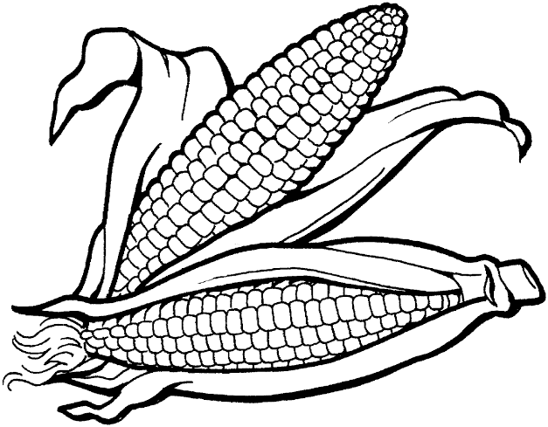
2. 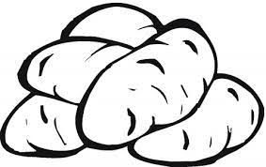
3. 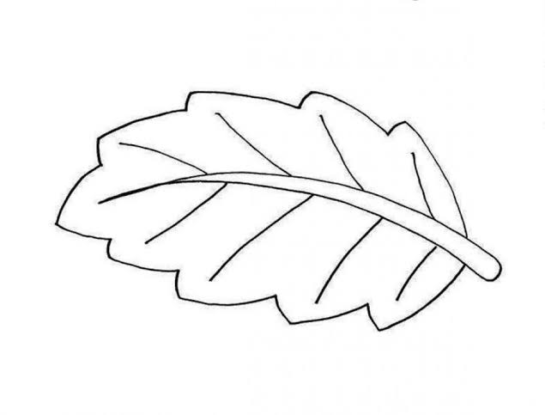
4. 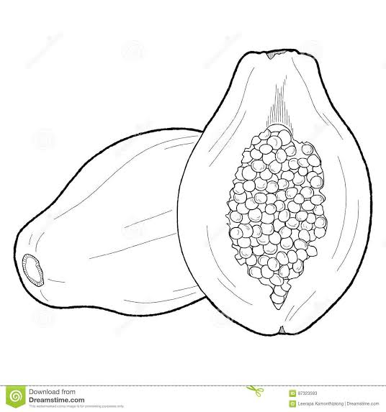
5. 

**THEORY**

1. State 1 use of: -
2. Stem Tubers
3. ____________________________
4. Root Tubers
5. ____________________________
6. What is a Balanced diet?

____________________________________________________________________________________________________________________________

2b. List all the classes of food you know

1. ____________________________
2. ____________________________
3. ____________________________
4. ____________________________
5. Write one effect of eating and unbalanced diet
6. ____________________________________________________________
7. Give 1 example of: -
8. Root Crops
9. _________________________

II) Stem Crops

1. ______________________

**PATFIN NURSERY AND PRIMARY SCHOOL, AKESAN, LAGOS STATE.**

**SECOND TERM EXAMINATION [ 2018 / 2019 ]**

**CLASS : Primary 2**

**NAME : _____________________________ SUBJECT: Vocational Aptitude**

**INSTRUCTION : ANSWER CORRECTLY DURATION : 1 HOUR**

**Objectives**

1. A place where food is prepared is called ____________. (a)room (b)kitchen (c)toilet
2. ________________ judges minor cases. (a)farmer (b)magistrate (c)doctors
3. Craftwork involves the making of object by using ___________. (a)hands (b)machine (c)electricity
4. _____________ ensures fair play on the football field. (a)coach (b)referee (c)teacher
5. ____________ is used in decorating. (a)balloons (b)cutlass (c)rake

**Answer True/False**

1. Event planning helps in making our event successful. (True/False)
2. Soccer game requires skill. (True/False)
3. A lawyer gives legal advice. (True/False)
4. Microwaving is a method of cooking food. (True/False)
5. Fire can be caused by gas leakage. (True/False)

**Answer Yes/No**

1. Law is a profession. (Yes/No)
2. Does a lawyer represent people in the court of law? (Yes/No)
3. Raffos is used in making mat. (Yes/No)
4. Barcelona is a club in Lagos. (Yes/No)
5. Can we use balloon to decorate in a party? (Yes/No)

**Fill in the gaps**

1. _____________ represents people in court.
2. _____________ is worn on the foot when playing ball.
3. Football is played for ___________ minutes.
4. An object used to hit the ball in tennis is called __________________
5. _______________ pots and fire

**PATFIN NURSERY AND PRIMARY SCHOOL, AKESAN, LAGOS STATE.**

**SECOND TERM EXAMINATION [ 2018 / 2019 ]**

**CLASS : Primary 2**

**NAME : _____________________________ SUBJECT: K. O. W.**

**INSTRUCTION : ANSWER CORRECTLY DURATION : 1 HOUR**

**Objectives**

1. ______________ is sport in America
2. _________________ is spent in Nigeria
3. ________________ is spent in Benin
4. ________________ is spent in UK
5. Yuri Gagarin travelled out of ________________
6. _____________ was the first woman to buy a car.

(a)jalako Tinubu (b)Efirin Tinubu (c)Efumoye Tinubu

1. ____________ mother was thrown down from a building.

(a)femi’s (b)Fade’s (c)Fela’s

1. ___________________ married lord lugard.

(a)Florence Shaw (b)Felicia Shaw (c)Flora Shaw

1. Nigeria was formerly known as _____________. (a)Niger Benin (b)Area Name (c)Niger Area
2. Nelson Mandela was born in ______________. (a)South Nigeria (b)South Europe (c)South Africa

**Answer True/False**

1. Nelson in also known as the Great Madiba. (True/False)
2. He fought the white people for being partial. (True/False)
3. Earth is the only planet that sustain life. (True/False)
4. Niger Area was made up of Kingdom. (True/False)
5. Paper is gotten from plants. (True/False)

**Answer Yes/No**

1. Herbert Macauley is the grandson of Bishop Ajayi Crowther. (True/False)
2. Mary Slessor stopped the killing of twins. (True/False)
3. Winger is a kind of season. (True/False)
4. Hamattan is a kind of season. (True/False)
5. Africa is a continent. (True/False)

**THEORY**

1. List all the continents
2. _____________________________
3. _____________________________
4. _____________________________
5. _____________________________
6. _____________________________
7. _____________________________
8. _____________________________
9. Write all you know about Nelson Mandela.

_______________________________________________________________________________________________________________________________________________________________________________________________________________________________________________________

1. Write 5 months of the year.
2. _____________________________
3. _____________________________
4. _____________________________
5. _____________________________
6. _____________________________
7. Answer these:

First Female University Vice Chancellor

_______________________________

**PATFIN NURSERY AND PRIMARY SCHOOL, AKESAN, LAGOS STATE.**

**SECOND TERM EXAMINATION [ 2018 / 2019 ]**

**CLASS : Primary 2**

**NAME : _____________________________ SUBJECT: Mathematics**

**INSTRUCTION : ANSWER CORRECTLY DURATION : 1 HOUR**

**Objectives**

**fill in the gaps**

1. 100, 200, _______, 400

$2×\left(5+3\right)=$

$12÷4=$

$26÷2=$

$100×0=$
2. _____________________
3. ______________________
4. _________________
5. _____________

**Choose the correct option**

$\frac{1}{2}+\frac{1}{2}=$

$32×3=$

$43×5=$

$24×2=$

$33×1=$

1. ___________________
2. _____________
3. _______________
4. ____________
5. ______________

**Answer True/False**

1. $4×4=15$ (True/False)
2. $3×8=$ 61 (True/False)
3. $3×(7+2)=27$ (True/False)
4. Any number multiplied by 1 gives that same number. (True/False)
5. Any number multiplied by zero. (True/False)
6. $21÷7=3$ (True/False)
7. $20÷10=10$ (True/False)
8. $36÷3=14$ (True/False)
9. If a chair has 4 legs, 5 chairs will have 20 legs. (True/False)
10. If an Apple has 4 seeds, then 16 Apples will have 30 seeds. (True/False)

**THEORY**

1. 1 7 5K

$×$ 4

1. N 2. 50

$×$ 4

$×9=81$

1. ______________

3b.) $4×_________=20$

1. Factors of 2 up to 10 series
2. Factors of 3 up to 10 series